**Program 1:**

marks=int(input("Enter your percentage: "))

if marks>90:

print("Your grade is : A")

elif marks>80 and marks<=90:

print("Your grade is : B")

elif marks>60 and marks<=80:

print("Your grade is : C")

else:

print("Your grade is : D")

**Program 2:**

cost=int(input("Enter the cost of a Bike: "))

if cost > 100000:

print("Road tax to be paid: ", 0.15*cost)

elif cost > 50000 and cost<= 100000:

print("Road tax to be paid: ", 0.1*cost)

else:

print("Road tax to be paid: ", 0.05*cost)

**Program 3:**

city=input("Enter the name of the city: ")

if city=="Delhi":

print(f"Monument of {city} is Red Fort.")

elif city=="Agra":

print(f"Monument of {city} is Taj Mahal.")

elif city=="Jaipur":

print(f"Monument of {city} is Jal Mahal.")

**Program 4:**

num=int(input("Enter a number"))

n=0

x=num

while num>10:

num=num/3

n=n+1

print(f"{x} can {n-1} times divisible by 3 before it is less than or equal to 10.")

**Question 5:**

Python while loop is used to run a block code until a certain condition is met.

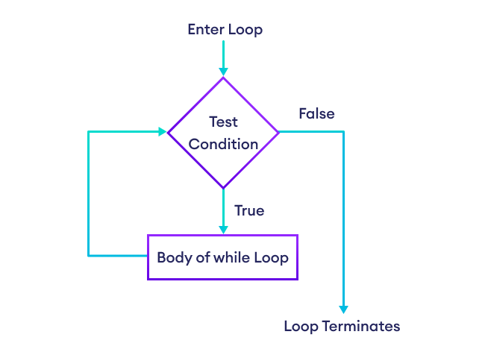

**Example:**

i = 1

n = 5

while i <= n:

print(i)

i = i + 1

| **Variable (i and n)** | **Condition (i<=n)** | **Action** |
| --- | --- | --- |
| i=1 and n=5 | True | 1 is printed. i is increased to 2. |
| i=2 and n=5 | True | 2 is printed. i is increased to 3. |
| i=3 and n=5 | True | 3 is printed. i is increased to 4. |
| i=4 and n=5 | True | 4 is printed. i is increased to 5. |
| i=5 and n=5 | True | 5 is printed. i is increased to 6. |
| i=6 and n=5 | False | The loop is terminated. |

**Program 6:**

**Pattern 1:**

i=1

while i<=5:

j=1

while j<=i:

print("*", end=" ")

j+=1

print()

i+=1

**Output**

*

* *

* * *

* * * *

* * * * *

**Pattern 2:**

i=1

while i<=5:

j=6-i

while j>0:

print(j, end=" ")

j-=1

print()

i+=1

**Output:**

**5 4 3 2 1**

**4 3 2 1**

**3 2 1**

**2 1**

**1**

**Pattern 3:**

i=1

while i<=5:

j=5

while j>=i:

print("*", end=" ")

j-=1

print()

i+=1

**Output:**

**\* * * * \***

**\* * * \***

**\* * \***

**\* \***

**\***

**Program 7 and 8:**

i=10

while i>0:

print(i)

i-=1

**Output:**

10

9

8

7

6

5

4

3

2

1